**Nama : Eliase Moses  
Kelas : Basic QE-D**

**Jawaban Soal Prioritas 2**

**Jawaban :**

**Test Positive**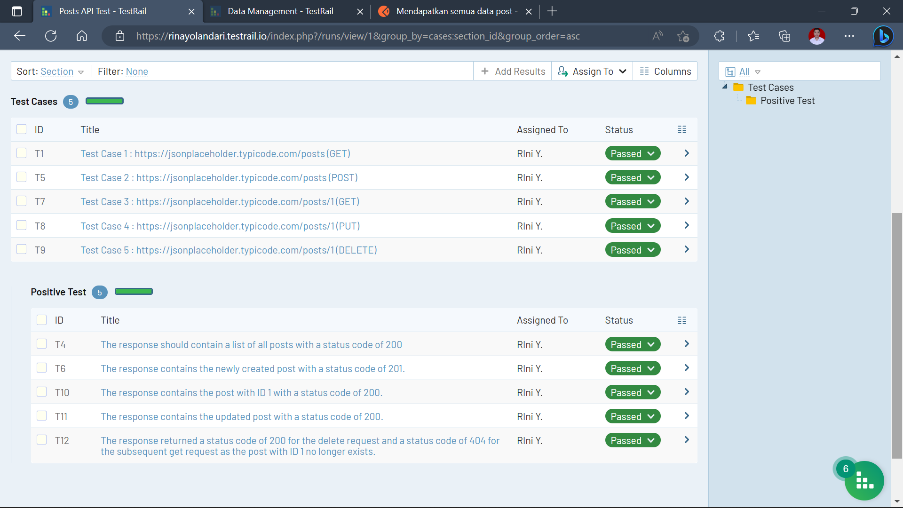

Pada test cases diatas menguji 5 test cases yang tertera dengan masing-masing metode yang ada dimana positive test nya terdiri dari 5 cases sama seperti excel yakni :

Langkah 1 (GET) : 1. Send GET request to the endpoint. <br>  
 2. Verify that the response status code is 200. <br>  
 3. Verify that the response contains a list of posts.

Langkah 2 (POST) : 1. Send POST request to the endpoint with a new post payload. <br>  
 2. Verify that the response status code is 201. <br>  
 3. Verify that the response contains the newly created post.

Langkah 3 (GET) : 1. Send GET request to the endpoint. <br>  
 2. Verify that the response status code is 200. <br>  
 3. Verify that the response contains the post with ID 1.

Langkah 4 (PUT) : 1. Send PUT request to the endpoint with an updated post payload. <br>  
 2. Verify that the response status code is 200. <br>  
 3. Send GET request to the endpoint. <br>  
 4. Verify that the response contains the updated post.

Langkah 5 (DELETE) : 1. Send DELETE request to the endpoint. <br>  
 2. Verify that the response status code is 200. <br>

**atau**  
 3. Send GET request to the endpoint. <br>  
 4. Verify that the response status code is 404.

**Test Negative**

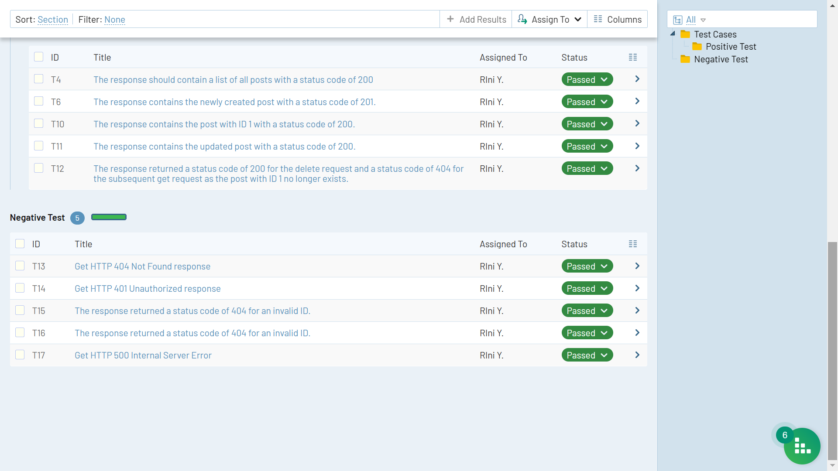

Pada test cases diatas menguji 5 test cases yang tertera dengan masing-masing metode yang ada dimana positive test nya terdiri dari 5 cases sama seperti excel yakni :

Langkah 1 (GET) : 1. Send GET request to the endpoint with an invalid URL. <br>  
 2. Verify that the response status code is 404.

Langkah 2 (POST) : 1. Send POST request to the endpoint with an invalid payload. <br>  
 2. Verify that the response status code is 400.

Langkah 3 (GET) : 1. Send GET request to the endpoint with an invalid ID. <br>  
 2. Verify that the response status code is 404.

Langkah 4 (PUT) : 1. Send PUT request to the endpoint with an invalid ID and an updated

payload. <br>  
 2. Verify that the response status code is 404.

Langkah 5 (DELETE) : 1. Send DELETE request to the endpoint with an invalid ID. <br>  
 2. Verify that the response status code is 404.